NYLON RANGE by Olivari of Italy
Model No. | Colour | Description | Stock on Hand
M501 | White | ‘Boma’ Nylon Door Handles | 1075
M501 | Black | ‘Boma’ Nylon Door Handles | 817
M501 | Brown | ‘Boma’ Nylon Door Handles | 237
M501 | Grey | ‘Boma’ Nylon Door Handles | 692
M501 | Red | ‘Boma’ Nylon Door Handles | 655
M501 | Burgundy | ‘Boma’ Nylon Door Handles | 418
M501 | Yellow | ‘Boma’ Nylon Door Handles | 227
M501 Total |  |  | 4121

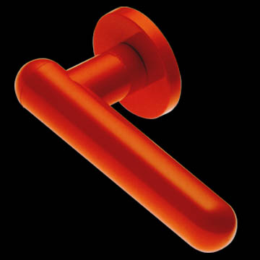

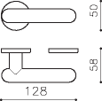

Description:
Boma Door Handles made from Industrial Strength Nylon. Manufactured in Italy. Normal Sell Price of $34.00 + GST per set.

Colours:
White, Black, Brown, Grey, Red, Burgundy, Yellow

Model No. | Colour | Description | Stock on Hand
M507 | White | ‘Iseo’ Nylon Door Handles | 114
M507 | Black | ‘Iseo’ Nylon Door Handles | 597
M507 | Brown | ‘Iseo’ Nylon Door Handles | 809
M507 | Red | ‘Iseo’ Nylon Door Handles | 821
M507 | Burgundy | ‘Iseo’ Nylon Door Handles | 117
M507 | Yellow | ‘Iseo’ Nylon Door Handles | 652
M507 Total |  |  | 3110
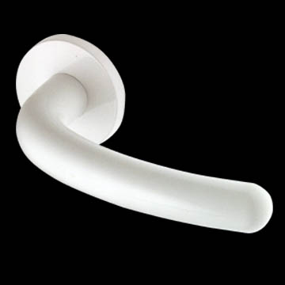

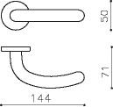

Description:
Iseo Door Handles made from Industrial Strength Nylon. Manufactured in Italy. Normal Sell Price of $34.00 + GST per set.

Colours:
White, Black, Brown, Red, Burgundy, Yellow

Model No. | Colour | Description | Stock on Hand
M401 | Red | ‘Cusio’ Nylon Door Handles | 150
M401 Total |  |  | 150
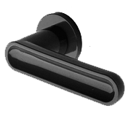

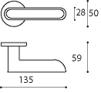

Description:
Cusio Door Handles made from Industrial Strength Nylon. Manufactured in Italy. Normal Sell Price of $34.00 + GST per set.

Colours:
Red

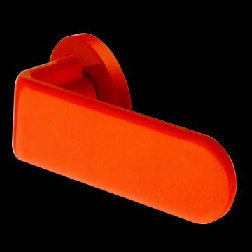

Model No. | Colour | Description | Stock on Hand
M503 | White | ‘Lario’ Nylon Door Handles | 313
M503 | Red | ‘Lario’ Nylon Door Handles | 454
M503 | Burgundy | ‘Lario’ Nylon Door Handles | 366
M503 Total |  |  | 1133

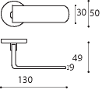

Description:
Lario Door Handles made from Industrial Strength Nylon. Manufactured in Italy. Normal Sell Price of $34.00 + GST per set.

Colours:
White, Red, Burgundy

Model No. | Colour | Description | Stock on Hand
M504 | Black | ‘Montecarlo’ Nylon Door Handles | 514
M504 | Black & Burgundy | ‘Montecarlo’ Nylon Door Handles | 184
M504 Total |  |  | 698
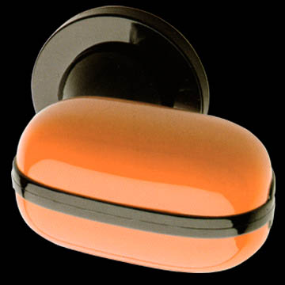

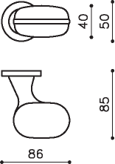

Description:
Montecarlo Door Handles made from Industrial Strength Nylon. Manufactured in Italy. Normal Sell Price of $34.00 + GST per set.

Colours:
Black, Black & Burgundy

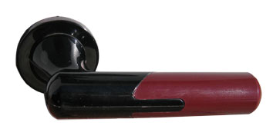

Model No. | Colour | Description | Stock on Hand
M404 | Black & Burgundy | ‘St Roma’ Nylon Door Handles | 241
M404 Total |  |  | 241

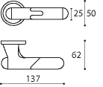

Description:
St Roma Door Handles made from Industrial Strength Nylon. Manufactured in Italy. Normal Sell Price of $34.00 + GST per set.

Colours:
Black & Burgundy

